Readme Instructions on how to run DreamSavers

Requirements:

Latest version of Python - <https://www.python.org/ftp/python/3.11.3/python-3.11.3-amd64.exe>.

PIL (Pillow) library

VSCode - <https://code.visualstudio.com/download>.

Install Python:

1. Download Python

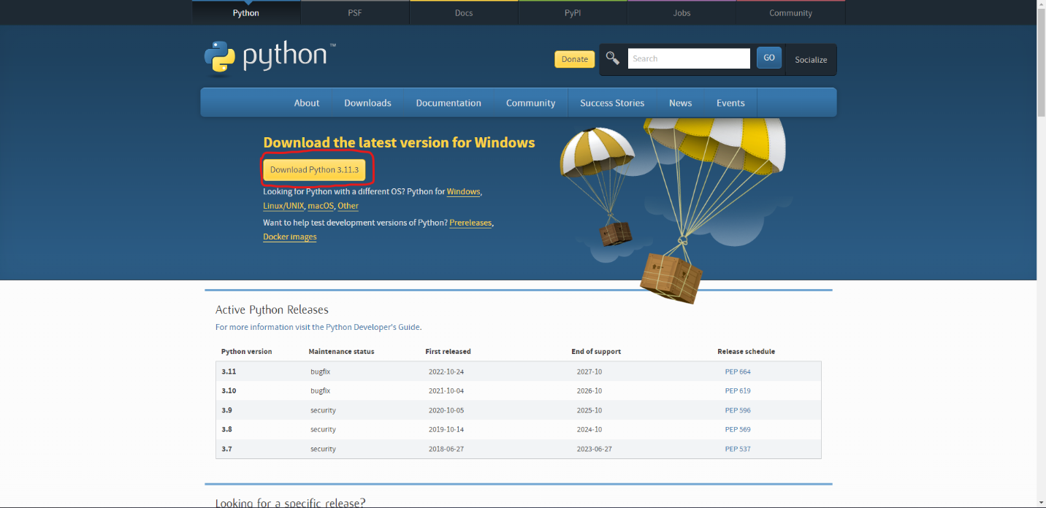

2. Make sure that the two check boxes are checked and Click Customize Installation

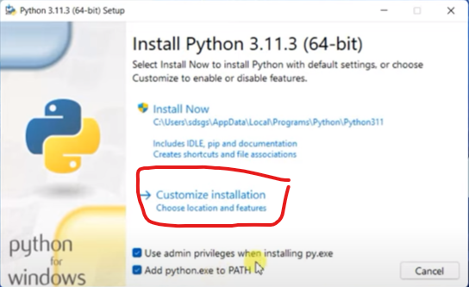

Courtesy: Geeky Scripts | YouTube <https://www.youtube.com/watch?v=FtpkXdH9jro>

3. Make sure to check all of the checkboxes and then click next

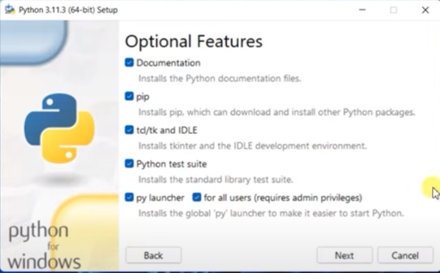

Courtesy: Geeky Scripts | YouTube <https://www.youtube.com/watch?v=FtpkXdH9jro>

4. Make sure to check these checkboxes and then click Install

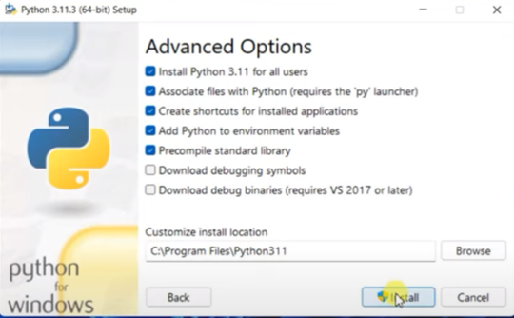

Courtesy: Geeky Scripts | YouTube <https://www.youtube.com/watch?v=FtpkXdH9jro>

5. After Installation, click close

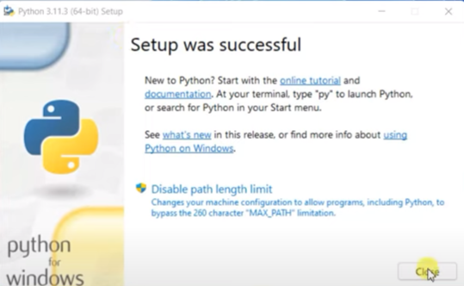

Courtesy: Geeky Scripts | YouTube <https://www.youtube.com/watch?v=FtpkXdH9jro>

Install VSCode with Extensions:

1. On Download click on the platform according to your operating system and open the installer

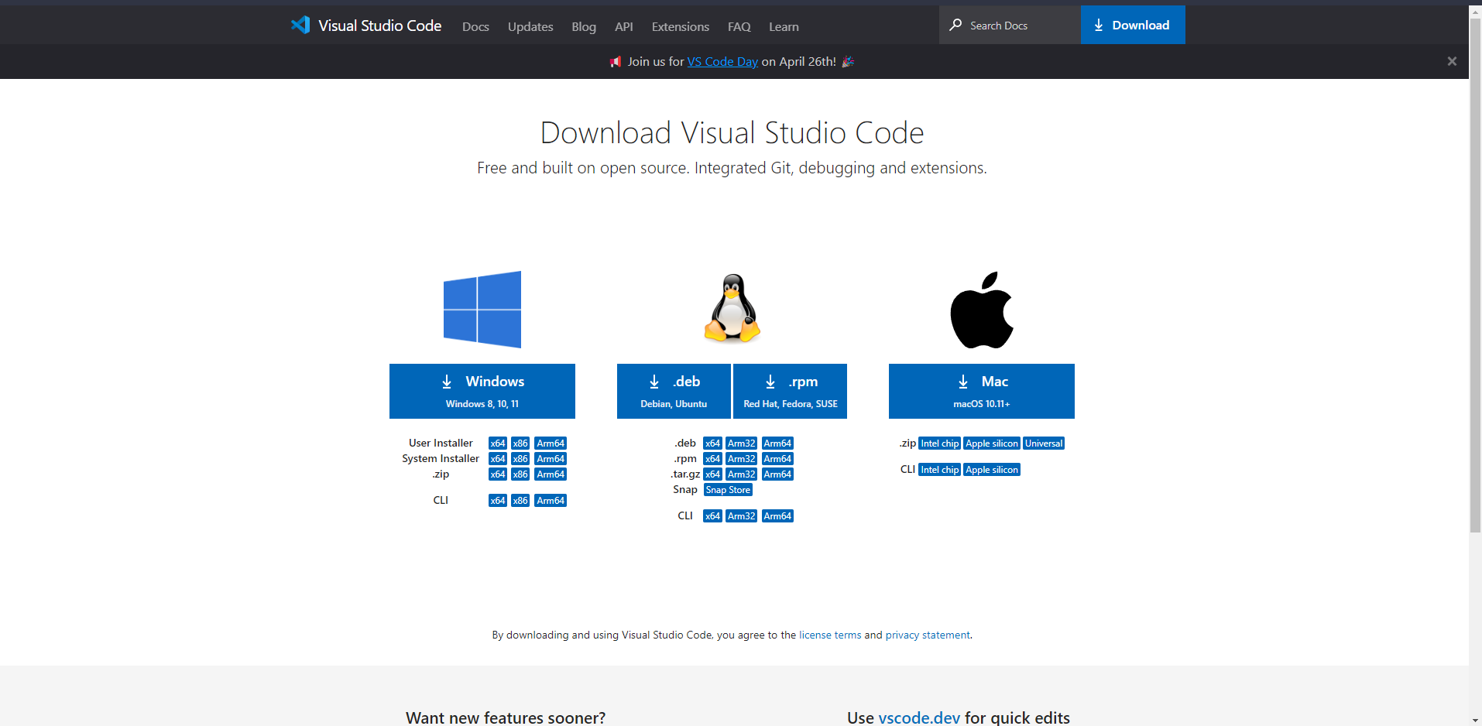

2. On setup, click I agree, and then click install

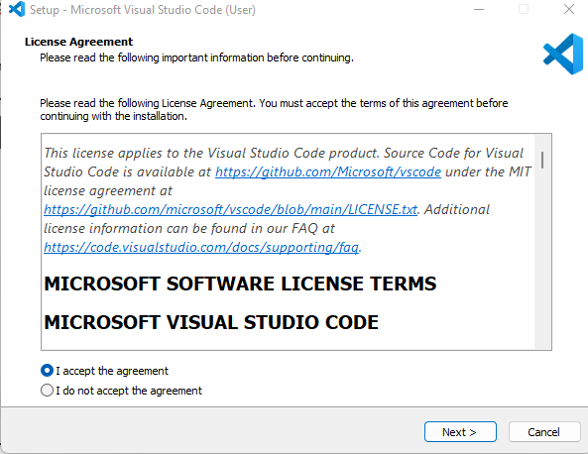

3. Click Next

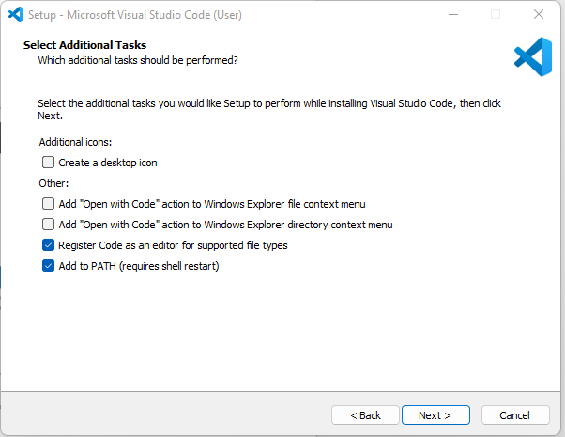

4. Click Install

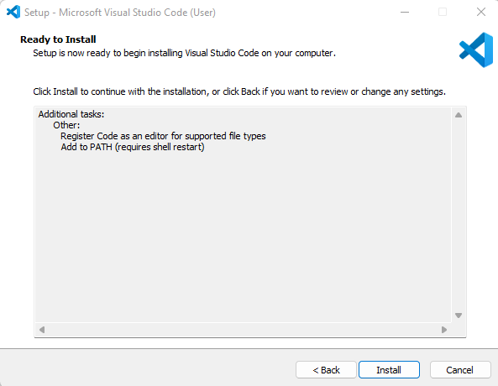

5. Click Finish

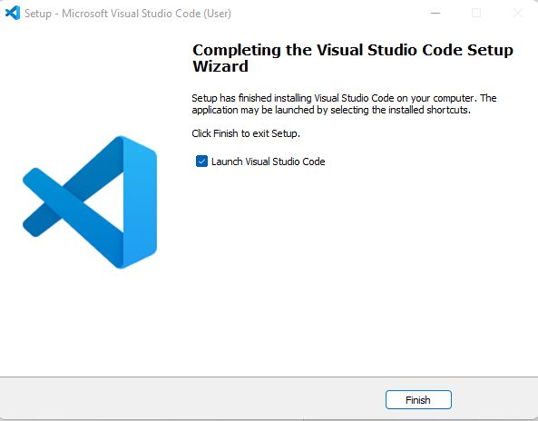

6. Upon launching the code editor, go to Extensions

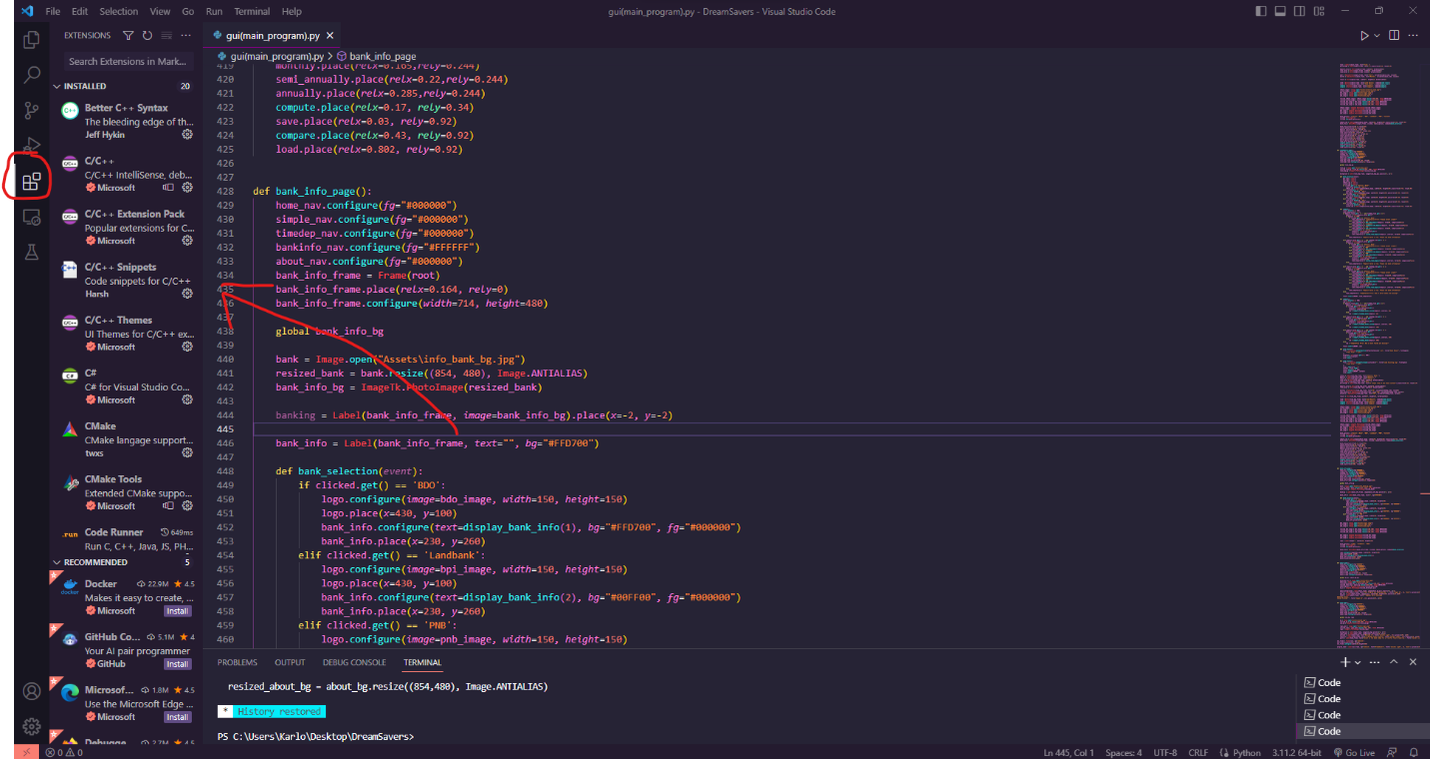

7. Search for Code Runner

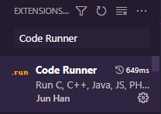

8. Click Install if Code Runner is not installed in the code editor.

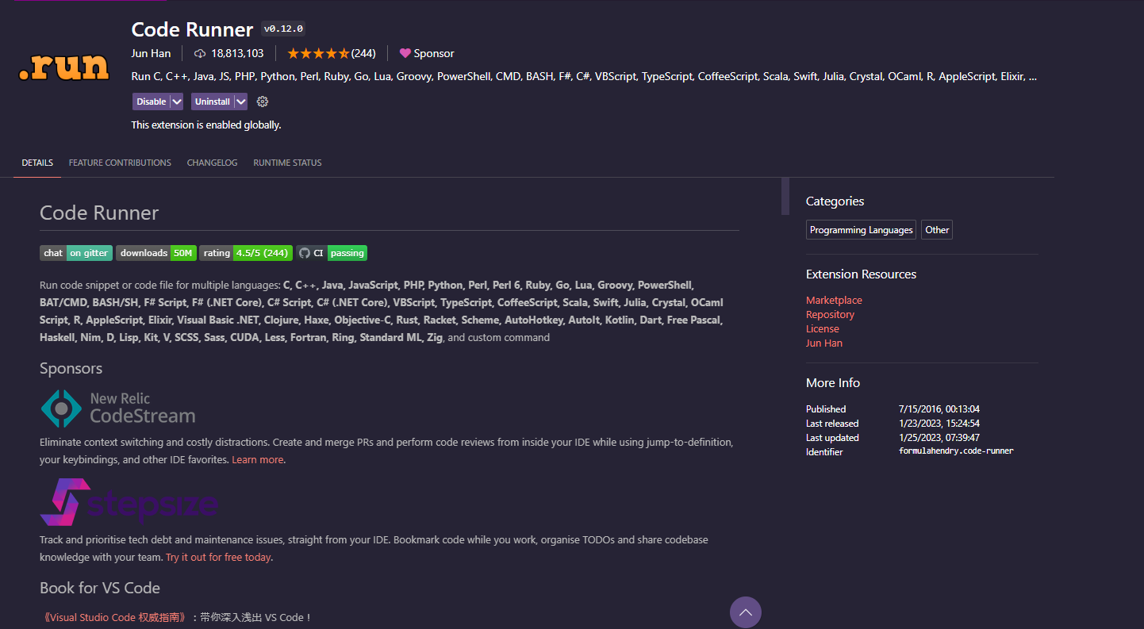

Installing Pillow

1. Right Click on Start button then click Windows Terminal (Admin)/ Windows Powershell (Admin)/ Command Prompt (Admin)

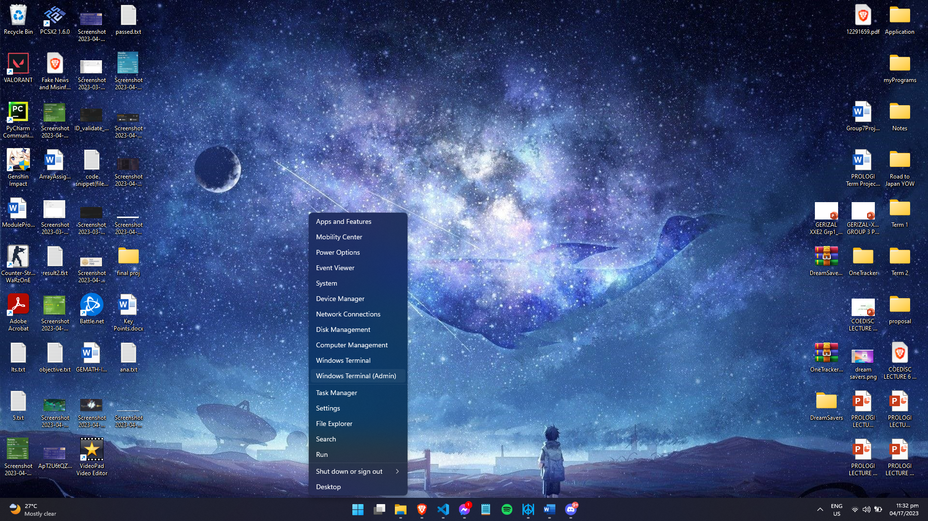

2. On Windows Terminal/Windows Powershell/Command Prompt, type “pip install pillow” and then click Enter

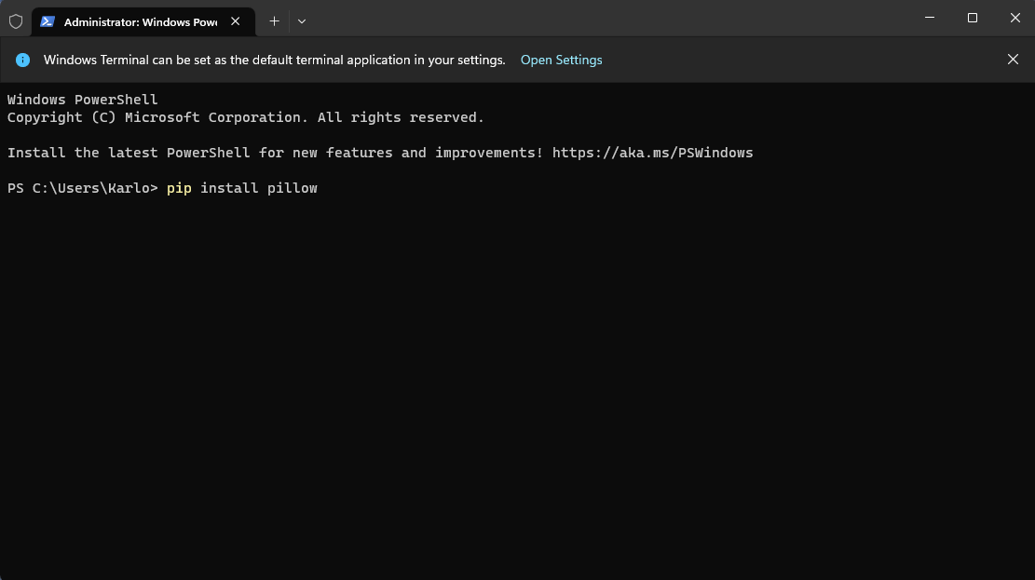

3. Wait until the installation is finished. After that close the terminal

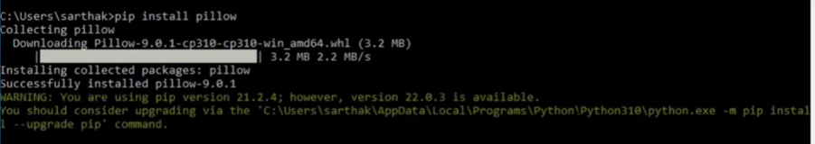

Courtesy: ProgrammingFever | YouTube: <https://www.youtube.com/watch?v=KdLyS_tAvjY>

Opening DreamSavers

1. Extract the Zip File

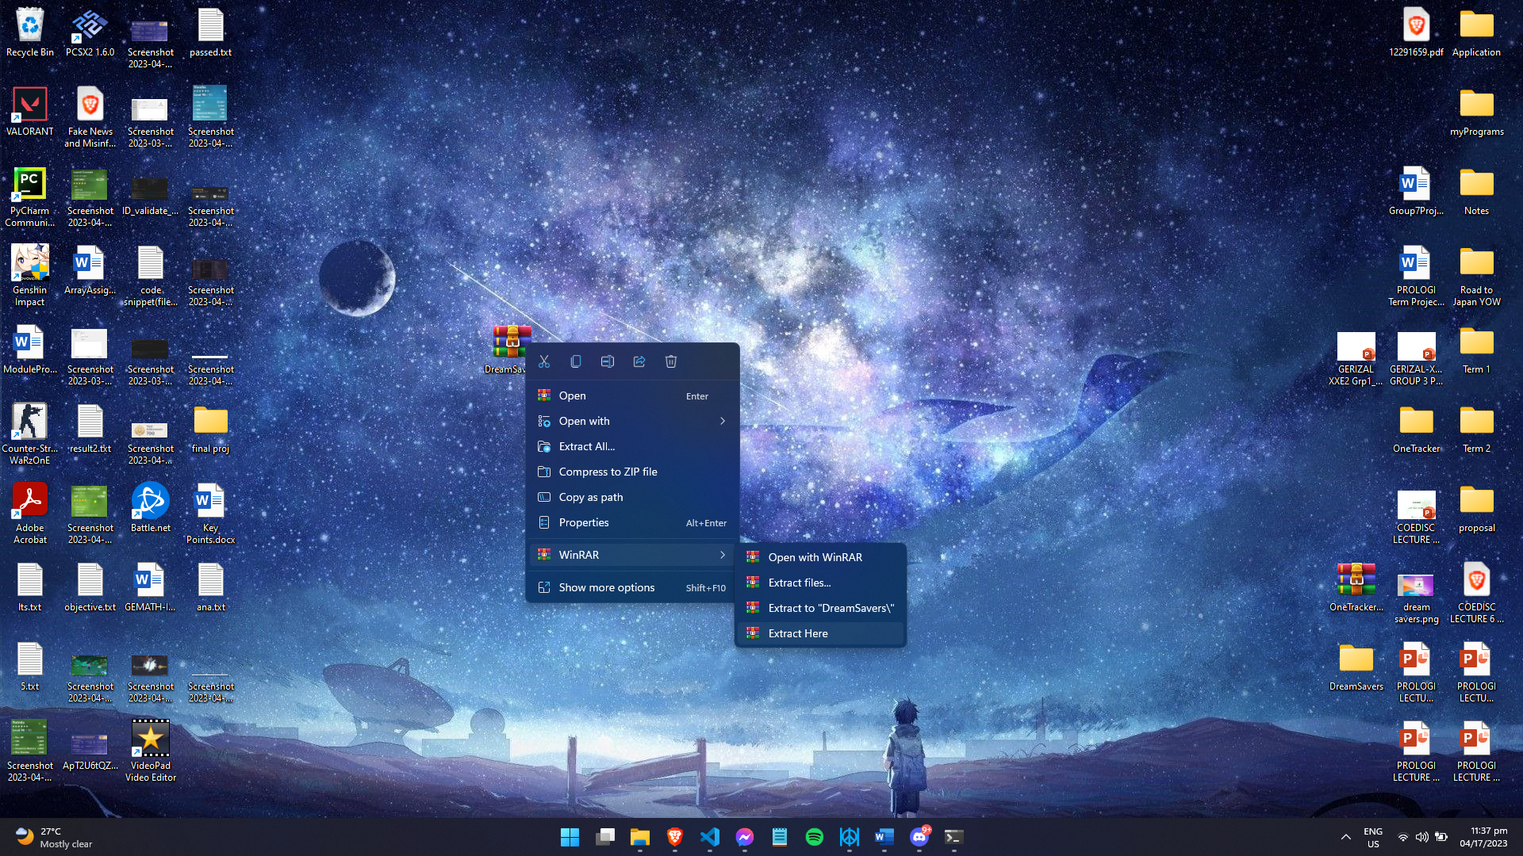

2. Open VSCode and in File Tab, Click Open Folder:

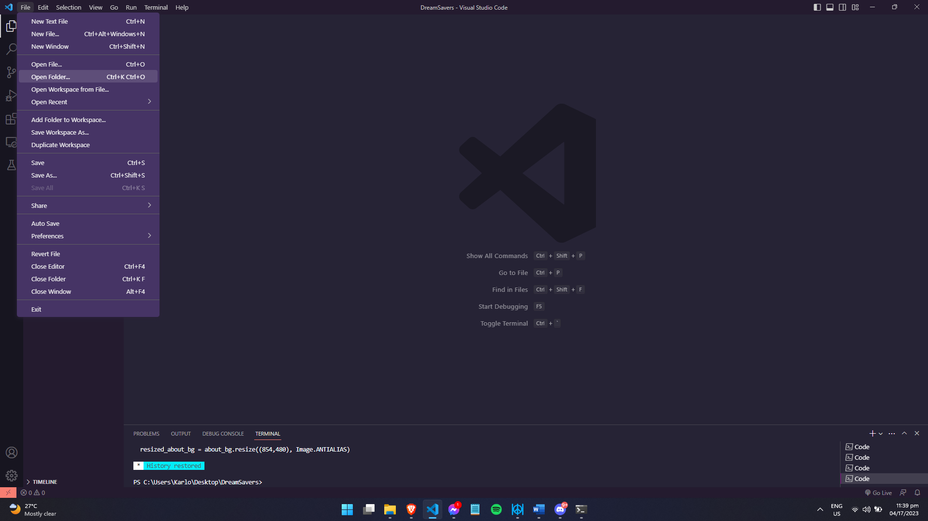

3. Choose DreamSavers Folder

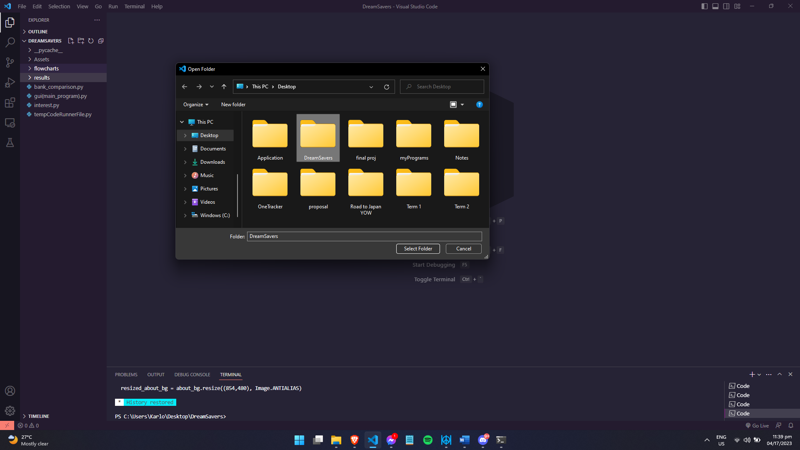

4. After Opening the folder, click on gui(main_program).py

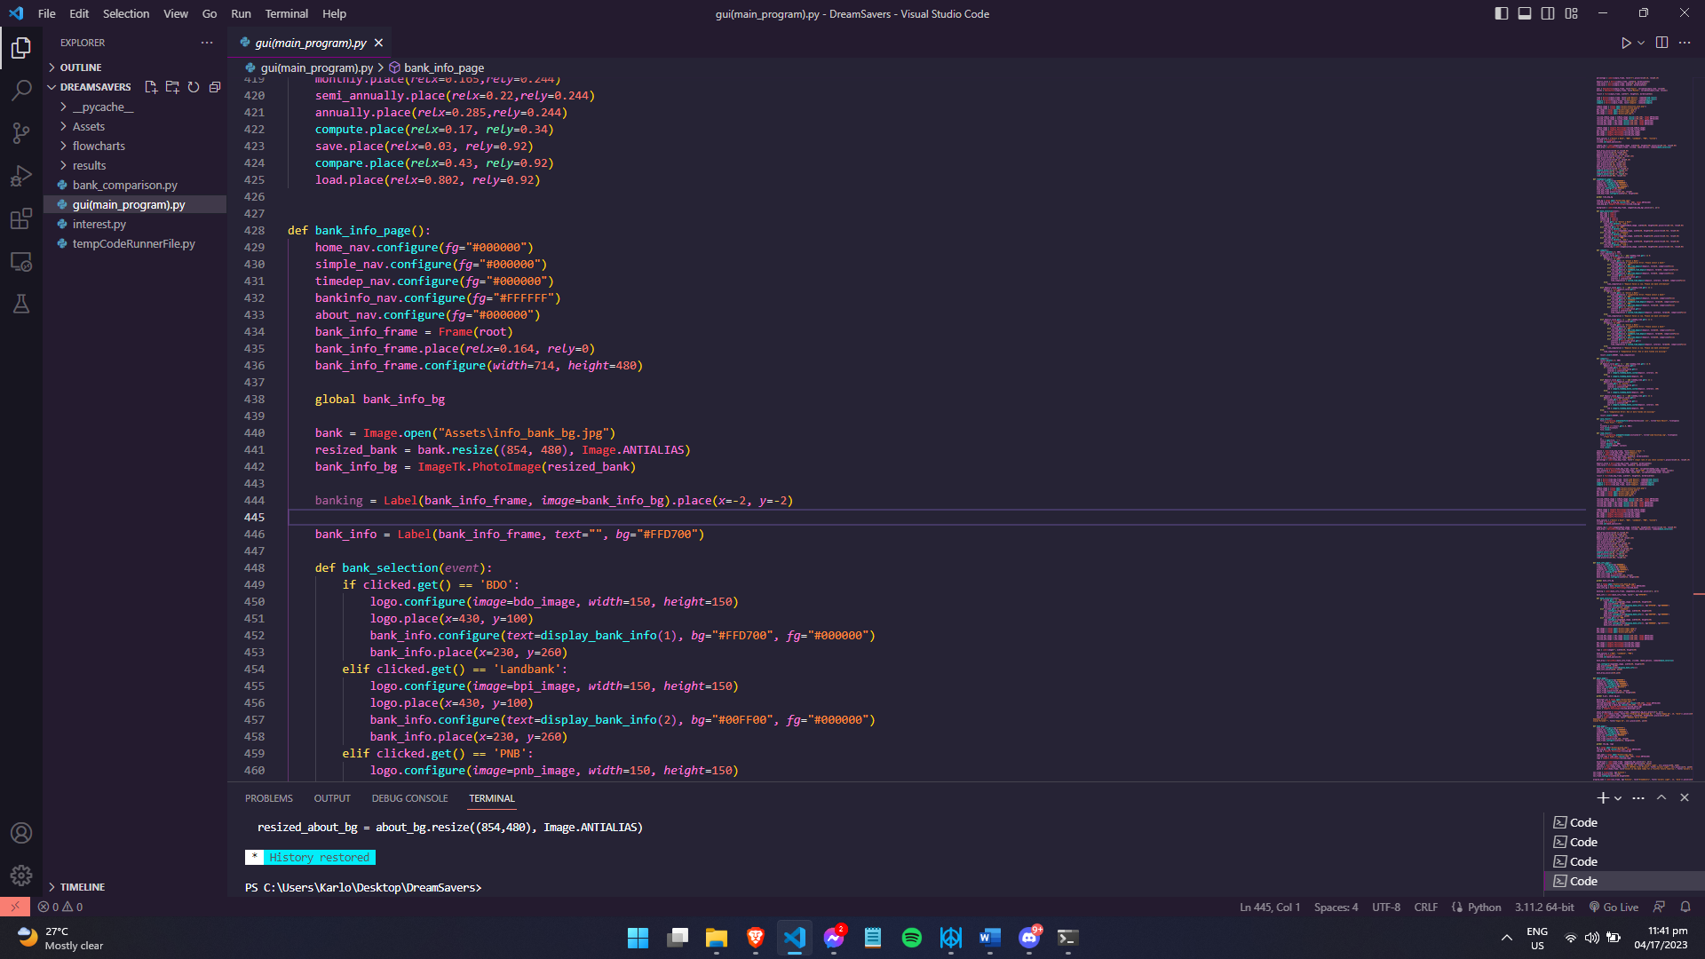

5. Click the run button on the top-right corner

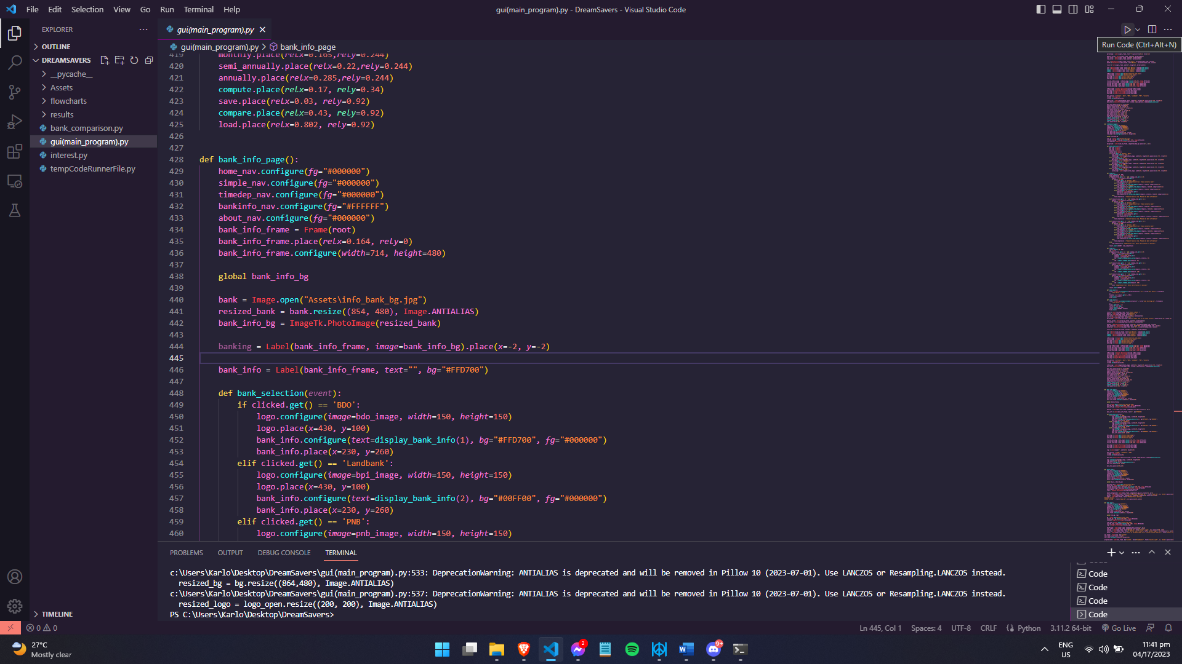

6. The program will now run. Enjoy 😊

